## Installation Jenkins on Amazon Linux.

**Prerequisites:**

**Minimum hardware requirements:**

* **256 MB of RAM Enough for doing proof of concept (POC).**
* **1 GB of drive space (although 10 GB is a recommended minimum if running Jenkins as a Docker container) Recommended hardware configuration for a small team:**
* **4 GB+ of RAM.**
* **50 GB+ of drive space. Software requirements:**
* **Jenkins require Java-17 or later versions.**
* **Open Port.No 8080 in EC2-security group. (8080 is Default port of Jenkins)**

**Launch an Amazon Linux EC2 instance.**

* **instance-type: t2.micro**

**Download Jenkins.**

**Go to Jenkins Download page:-**[**https://www.jenkins.io/download/**](https://www.jenkins.io/download/)

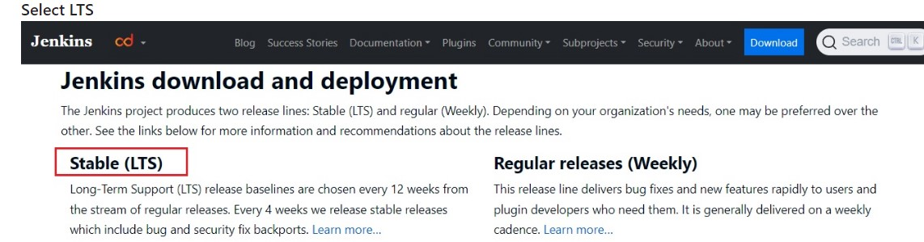

**Select Red Hat/Fedora/Alma/Rocky/CentOS**

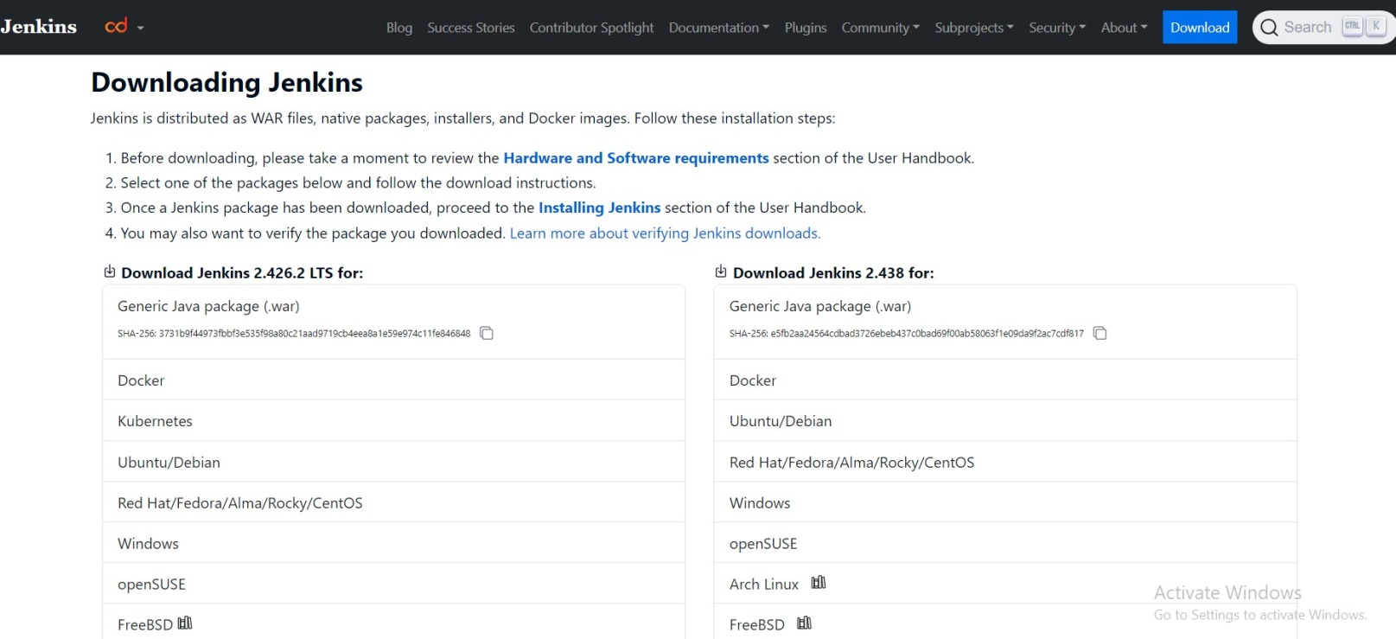

**We will see following command**

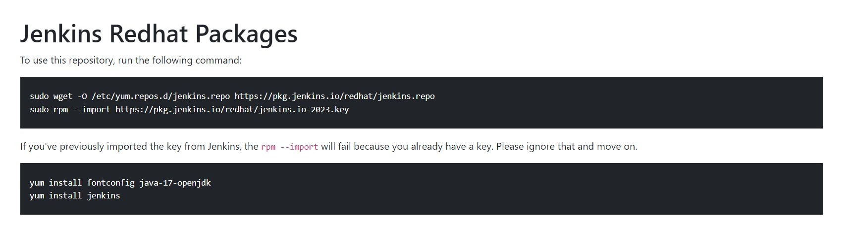

**Connect to instance and execute following commands.**

**# Become a root**

**sudo su -**

**# Jenkins repo is added to yum.repos.d**

**sudo wget -O /etc/yum.repos.d/jenkins.repo** [**https://pkg.jenkins.io/redhat-stable/jenkins.repo**](https://pkg.jenkins.io/redhat-stable/jenkins.repo)

****

**# Import key from Jenkins**

**sudo rpm --import https://pkg.jenkins.io/redhat-stable/jenkins.io-2023.key**

****

**# Install Java-17**

**sudo dnf install java-17-amazon-corretto –y**

**C:\Users\LENOVO\AppData\Local\Packages\Microsoft.Windows.Photos_8wekyb3d8bbwe\TempState\ShareServiceTempFolder\2024-01-02 17 34 29.jpeg**

**# Install Jenkins**

**yum install jenkins –y**

**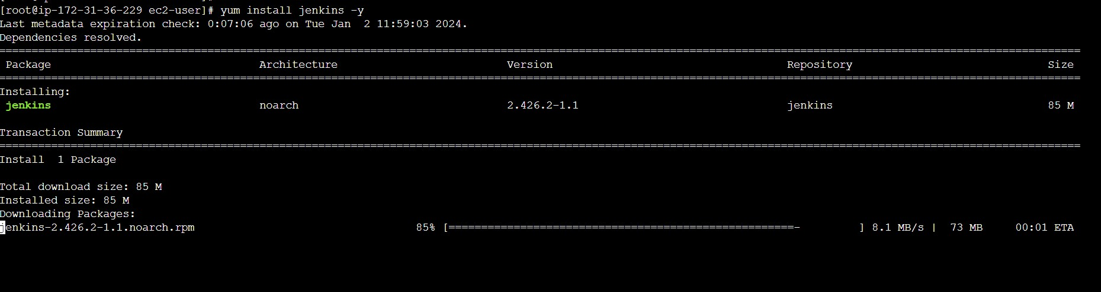**

**#sudo dnf install java-17-amazon-corretto -y**

**C:\Users\LENOVO\AppData\Local\Packages\Microsoft.Windows.Photos_8wekyb3d8bbwe\TempState\ShareServiceTempFolder\2024-01-02 17 34 29.jpeg**

**Start Jenkins.**

**# Become a root, no need to execute if you are alread root.**

**sudo su -**

**# You can enable the Jenkins service to start at boot with the command:**

**systemctl enable Jenkins**

****

**# You can start the Jenkins service with the command:**

**systemctl start Jenkins**

**C:\Users\LENOVO\AppData\Local\Packages\Microsoft.Windows.Photos_8wekyb3d8bbwe\TempState\ShareServiceTempFolder\2024-01-02 17 44 46.jpeg**

**# You can check the status of the Jenkins service using the command:**

**systemctl status jenkins**

**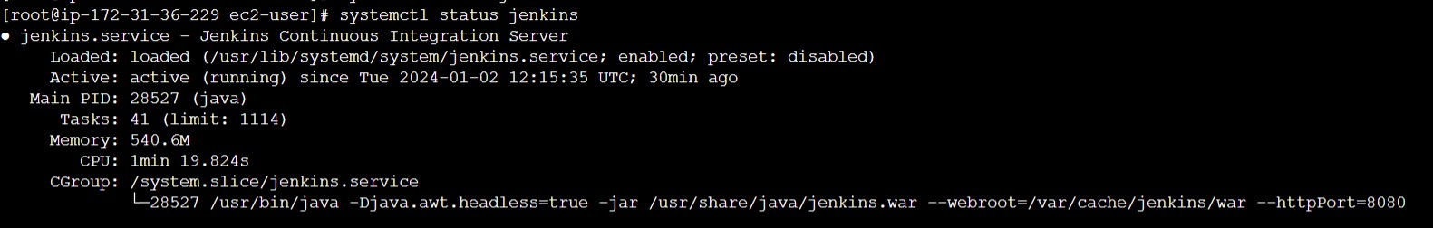**

**Open Web-Browser and access jenkins on port 8080.**

**http://<Public-IPv4-address>:8080/**

**C:\Users\LENOVO\AppData\Local\Packages\Microsoft.Windows.Photos_8wekyb3d8bbwe\TempState\ShareServiceTempFolder\2024-01-02 18 20 13.jpeg**

### The following page we get

**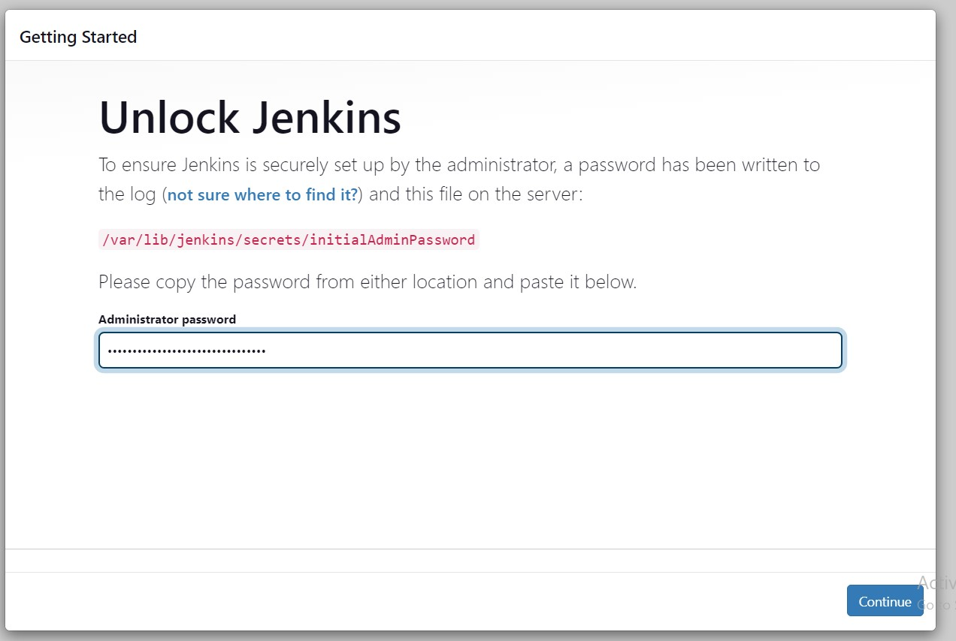**

**cat /var/lib/jenkins/secrets/initialAdminPassword**

**# you will get the password.**

****

**Copy the Password and past in Web-Browser then press continue.**

****

**Go with Install Suggested Plugins.**

**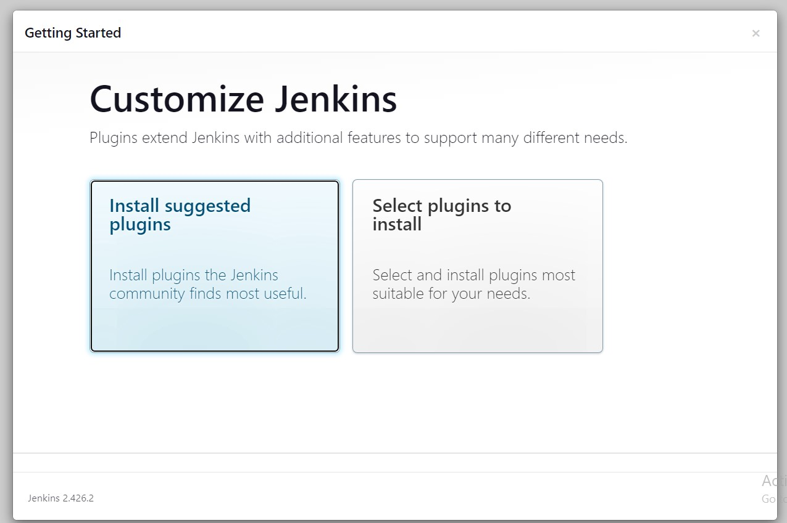**

**Suggested Plugins will start downloading.**

**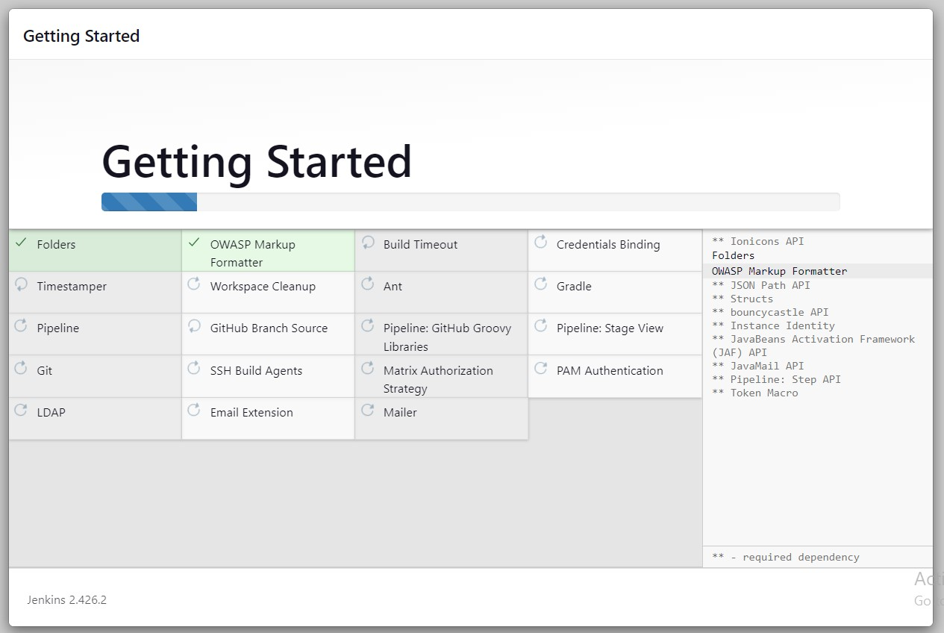**

**Fill the details and click save and continue.**

**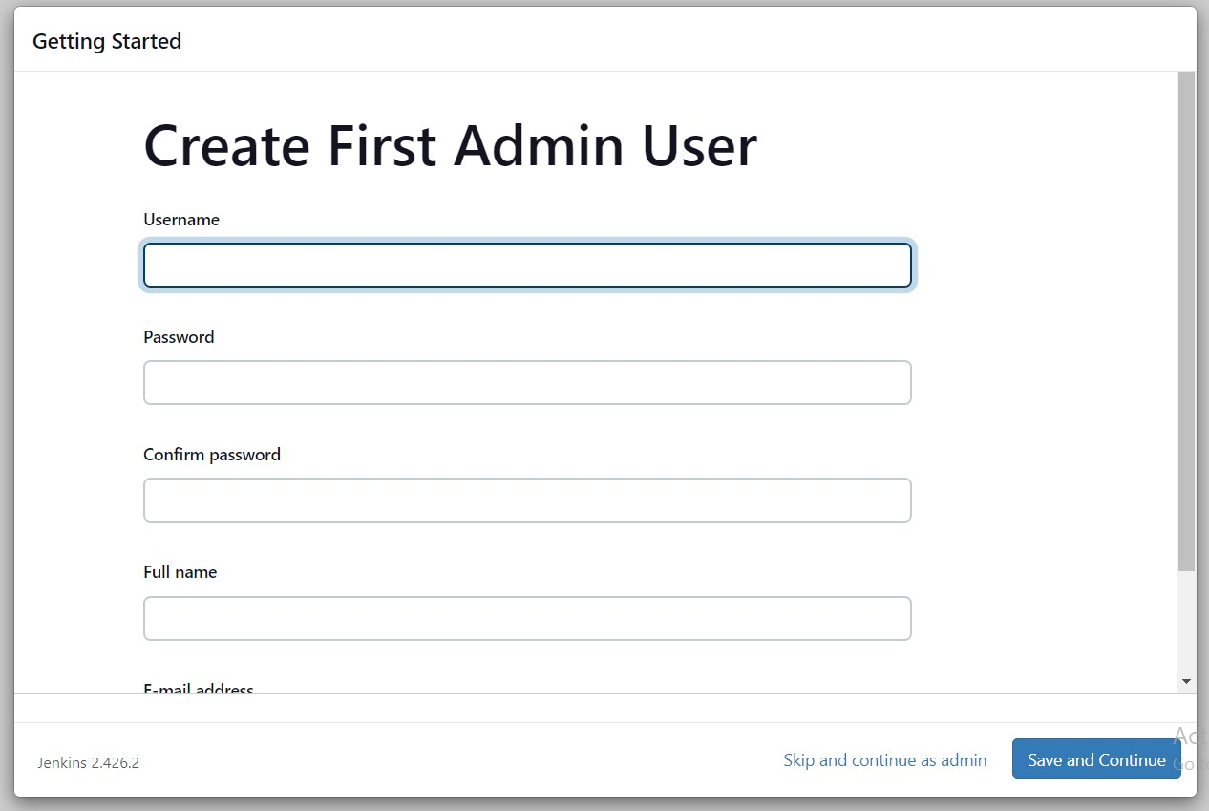**

**Click on Save and Finish.**

**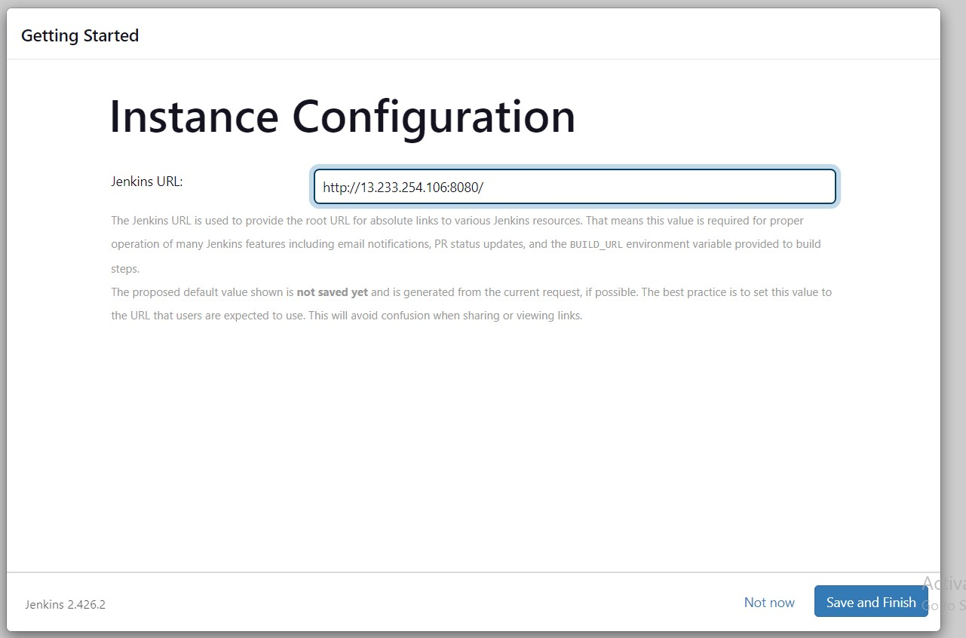**

**Jenkins is ready click on start using Jenkins**

**